

**Online Book Store**

**Project Advisor: D/ Amani Ashraf**





|  |
| --- |
| Mahmoud Mohamed  Abd El Fattah Mohamed |

Mostafa ahmed mostafa ali

Mahmoud Elshazly khodary

**1.Introduction to Team Members and their skill set:**

|  |  |  |
| --- | --- | --- |
| Members Name | Skill Set | Tasks |
| Mahmoud mohamed Abd  El Fattah | Back-End, Testing, Documentation  Front-End, | Development of Module, Back-End Development, Testing,  Implementation of Website  Website Design, |
| Mustafa Ahmed  Mustafa | Back-End, Testing, Database, Documentation | Back-End Development, Implementation of Website, Project Testing, Database Implementation Module. |
| Mahmoud El Shazly Khedry | Documentation,  Testing | Structure and Layout**,** Login and Testing. |

**Features of our team for project implementation**

**1/ We provide more than one design for the project**

**2/ We offer the possibility that we can amend the project during the implementation stages according to the viewpoint of the project financier**

**3 / The cost of implementing the project is low because we are looking to gain experience**

**4/ The first goal of the project is not to earn money, but to gain experience**

**Content**

**\*\*\* Features of our team for project implementation**

**1/ Introduction to Team Members and their skill set:**

**2**/ **Introduction**

**3/** **Tools and Technology with reasoning:**

4/ **Use case Diagram**

5/ **Use case Description**

6/ **Context level data flow diagram**

7/**Class Diagram**

8/ **user and Admin sequence diagram**

9/ **logical and physical level**

10/ ***Feasibility study***

## Introduction

Books are very essential for each and every one of us in order to increase our knowledge. An online book store is a virtual store on the internet where customers can browse the catalog and select books of interest. At checkout time, items in the e-library will be presented as an order. At that time, more information will be needed to complete the request. Usually, the customer will be asked to fill online form. An e-mail notification is sent to the customer as soon as the order is placed.

This project intends different types of forms with many types of books like story, drama, romance, history, adventures, etc. it can manage studying of books online, customers can choose many types of books categories etc. Here, the user may select desired book and view its price. The user may even search for specific books on the website. Once the user selects a book, he / she then has to fill in a form and the book is provided for the user. A customer can login to his / her account, can browse any book of his / her own interest, and can view prices and other details of selected book, place his/her order and can select from payment options. User needs to register on the site before checking out so that, he / she can login using same ID and Password next time. User can select any payment option that he / she wish to, like Fast Cash, Credit / Debit card or Cash on delivery.

## 3. Tools and Technology with reasoning:

**Technology and Languages**

* **Bootstrap**

To design website layout and structure, HTML, CSS, and JavaScript these languages will be used

* **PHP**

For back end coding php will be used

* **Java**

For back end coding in android studio java will be used

**Application Tools**

* **XAMPP:**

For coding Php language Visual Studio will be used

* **Android studio**

For coding in java android studio is used.

* **API**

API is used to get response from server.

* **Web Server**

Web server is required for responding to the requests of clients

**Database**

* **MySQL**

MySQL will be used for Database Design and Development

**Documentation**

* **Microsoft Visio**

Microsoft Visio is used for Project Design and Diagrams

* **Microsoft word:**

Microsoft word is used for designing documentation

**Use case Diagram**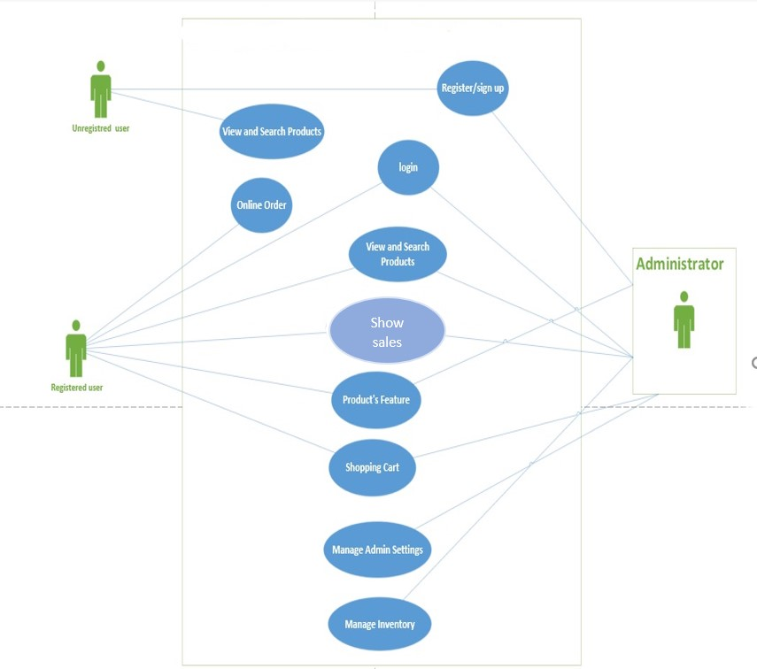

2.1.1. Use case Description

**Table 1: Use Case- User Registration**

|  |  |
| --- | --- |
| **ID:** | **UC_1** |
| **Title:** | **UC_ User Registration** |
| Description: | This module is specified for the users who are not registered to the application, and want to access additional features and functions. Here, at the time of registration, the user profile is created |
| Primary Actor: | User |
| Preconditions: | User open website and click on signup page. |
| Main Success Scenario: | 1. User enter his/her User Name, Gender, User Id, Password, Confirm Password, Date of birth, Email, Address, Contact No. 2. When the user inputs data into the fields and submits the form fields like email_id, password and mobile number are validated. 3. client machine and an activation link is sent to user’s mail account 4. And when user clicks on an activation link, his/her account is created and data is stored in user’s table. |
| Alternative Flow: | 1. User already register 2. User try wrong user name or password |
| Post-condition: | 1. Appropriate message will be displayed on the user’s screen. 2. User’s account is opened. |

**Table 2: Use Case- Sign In**

|  |  |
| --- | --- |
| **ID:** | **UC_2** |
| **Title:** | **UC_ Sign-In** |
| Description: | User will sign in to system. |
| Primary Actor: | User |
| Preconditions: | User is already registered |
| Main Success Scenario: | 1. User will enter the username and password. 2. System will verify the login |
| Alternative Flow: | 1. User login to his/her account 2. User entered wrong user name or password 3. User cannot login on system. |
| Post-condition: | Appropriate message will be displayed on the user’s screen. |

**Table 3: Use Case- Sign Out**

|  |  |
| --- | --- |
| **ID:** | **UC_3** |
| **Title:** | **UC_ Sign-out** |
| Description: | User will sign out to system. |
| Primary Actor: | User |
| Preconditions: | User is already signed in |
| Main Success Scenario: | 1. User will logout. 2. System will verify the logout |
| Alternative Flow: | 1. User logout to his/her account 2. User shutdown system/website |
| Post-condition: | 1. Appropriate message will be displayed on the user’s screen. 2. User’s account closed |

**Table 4: Use Case-Online order**

|  |  |
| --- | --- |
| **ID:** | **UC_4** |
| **Title:** | **UC_ online order** |
| Description: | The user will ordered products online which are available on our Website. |
| Primary Actor: | User |
| Preconditions: | 1. User logged in on app. |
| Main Success Scenario: | 1. Clicks products module. 2. Click on category. 3. Search for products 4. Check the available products. 5. Enter the details about products 6. Give information about himself 7. Click submit |
| Alternative Flow: | User cannot login on system.  User internet is not working. |
| Post-condition: | User will get verification message. |

**Table 5: Use Case-Cart Status**

|  |  |
| --- | --- |
| **ID:** | **UC_5** |
| **Title:** | **UC_ Cart-Status** |
| Description: | The user will see items present in cart |
| Primary Actor: | User |
| Preconditions: | User added item in cart. |
| Main Success Scenario: | Use can check its items to place order. |
| Alternative Flow: | User have no items in cart |
| Post-condition: | User will get verification message for order. |

**Table 6: Use Case-online store**

|  |  |
| --- | --- |
| **ID:** | **UC_6** |
| **Title:** | **UC_ online store** |
| Description: | The user will ordered products online which are available on our Website. |
| Primary Actor: | User |
| Preconditions: | 1. User logged in on website/Mobile App. |
| Main Success Scenario: | 1. Clicks products module. 2. Click on category. 3. Search for products 4. Check the available products. 5. Enter the details about products 6. Give information about himself 7. Click submit |
| Alternative Flow: | User cannot login on system.  User internet is not working. |
| Post-condition: | User will get verification message. |

**Table 7: Use Case-Order Status**

|  |  |
| --- | --- |
| **ID:** | **UC_7** |
| **Title:** | **UC_** Order-Status |
| Description: | The user will check its order progress |
| Primary Actor: | User |
| Preconditions: | User have placed order. |
| Main Success Scenario: | Order is placed and on its way to processed |
| Alternative Flow: | 1. Order cannot be placed 2. Order cannot be accepted due to invalid information |
| Post-condition: | User will get items ordered. |

**Table 8: Use Case Products Info**

|  |  |
| --- | --- |
| **ID:** | **UC_8** |
| **Title:** | **UC –** Product-Info |
| Description: | When administrator performs an operation like products addition the respective product are added in the database; hence, the whole product can be added. |
| Primary Actor: | Admin |
| Preconditions: | Admin logged on website as admin. |
| Main Success Scenario: | 1. Admin open product module. 2. Click on update or add product option. 3. product will be added or updated |
| Alternative Flow: | admin cannot login on admin account  Admin internet not working |
| Post-condition: | product delete or update successfully |

**Table 9: Use Case Products Category**

|  |  |
| --- | --- |
| **ID:** | **UC_9** |
| **Title:** | **UC –** Manage**-**Products-Category |
| Description: | When administrator performs an operation like managing product’s categories |
| Primary Actor: | Admin |
| Preconditions: | Admin logged on website as admin. |
| Main Success Scenario: | 1. Admin open product module. 2. Click on categories or add product option. 3. product will be added or updated in respective category |
| Alternative Flow: | admin cannot login on admin account  Admin internet not working |
| Post-condition: | Categories and products delete or update successfully |

**Table 10: Use Case- show sales**

|  |  |
| --- | --- |
| **ID:** | **UC_10** |
| **Title:** | **UC_ show sales** |
| Description: | The user “shall” get all types of products which are available on our Website and can search and Track location for specific products. |
| Primary Actor: | User |
| Preconditions: | 1. Visit the website |
| Main Success Scenario: | 1. Clicks products module. 2. Search for products 3. Track products |
| Alternative Flow: | User cannot have knowledge of how to use system |
| Post-condition: | User will get the location of product |

**Table 11: Use Case-Cart Item**

|  |  |
| --- | --- |
| **ID:** | **UC_11** |
| **Title:** | **UC_ Cart-Item** |
| Description: | The user will add items in cart |
| Primary Actor: | User |
| Preconditions: | User have logged in to system. |
| Main Success Scenario: | Use can add items to place order. |
| Alternative Flow: | 1. User have no items in cart 2. Cart is not working |
| Post-condition: | User can add item and place order. |

**Table 12: Use Case Products Inventory**

|  |  |
| --- | --- |
| **ID:** | **UC_12** |
| **Title:** | **UC –** Manage**-**Inventory |
| Description: | Administrator performs an operation like managing inventory system |
| Primary Actor: | Admin |
| Preconditions: | Admin logged on website as admin. |
| Main Success Scenario: | Admin can update inventory |
| Alternative Flow: | admin cannot login on admin account  Admin internet not working |
| Post-condition: | Inventory updated successfully |

**Context level data flow diagram**

## Class Diagram

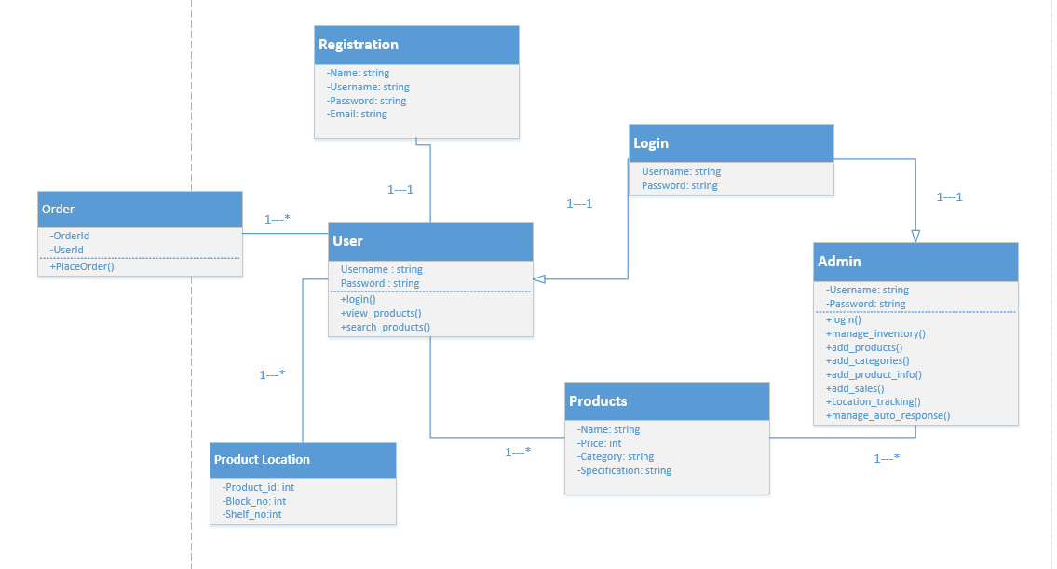

## user Sequence Diagram

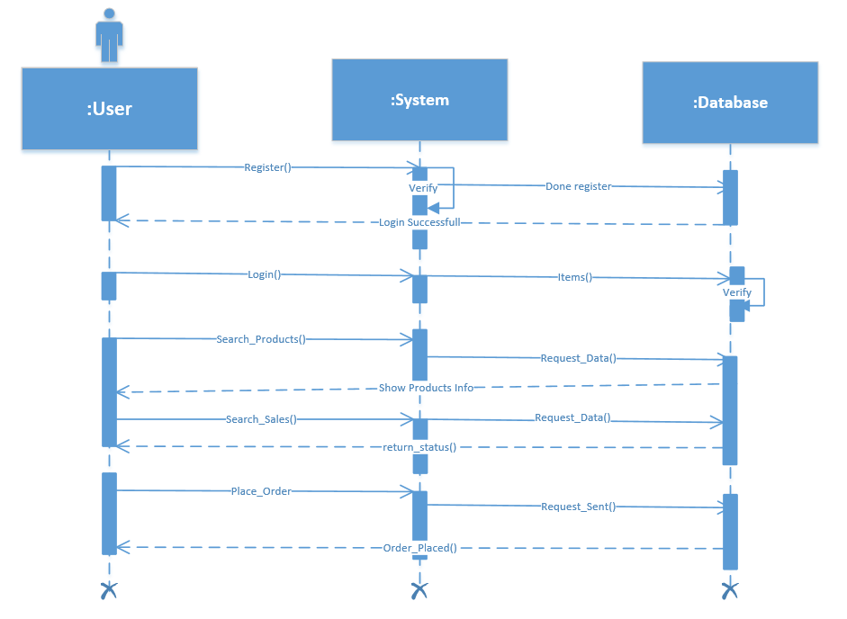

## Admin Sequence Diagram

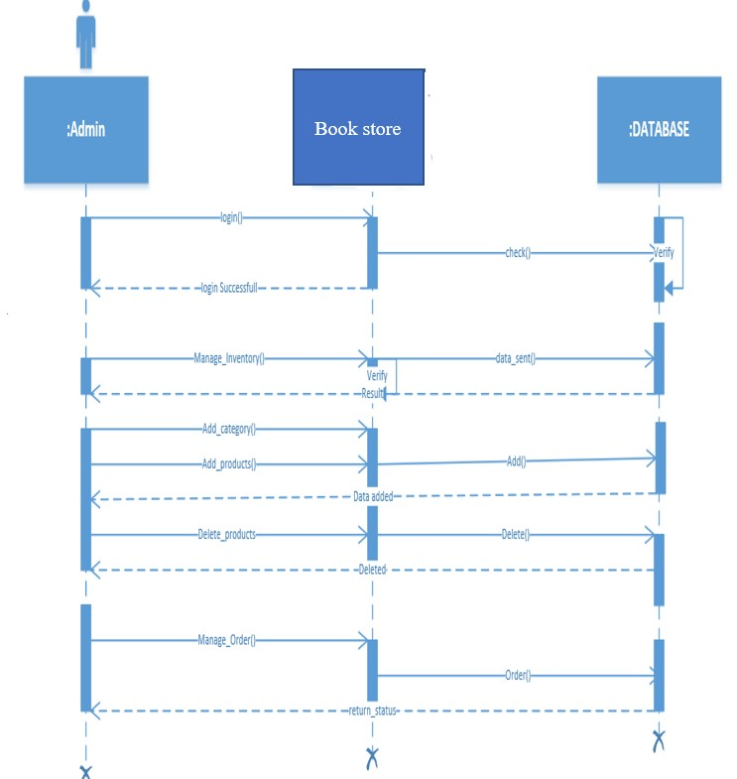



## data Model

The data model is a subset of the implementation model, which describes the logical and physical representation of persistent data in the system.

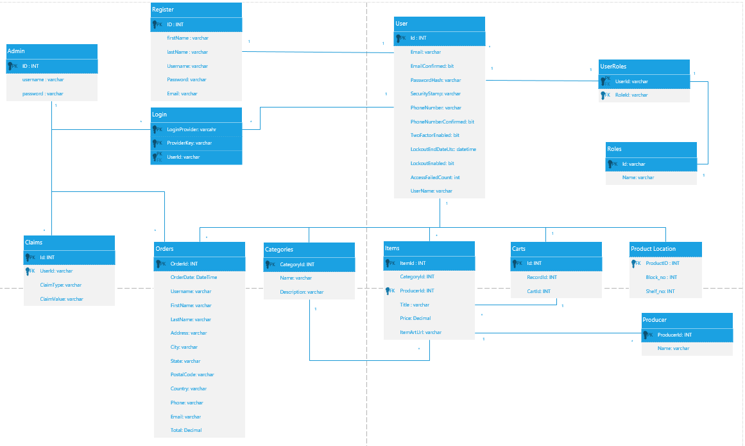

|  |  |  |  |  |  |
| --- | --- | --- | --- | --- | --- |
|  | Year 0 | Year 1 | Year 2 | Year 3 | Total |
| Total  Benefits |  | **20000** | **35000** | **40000** | **95000** |
| Total  Costs | **25000** | **12500** | **17000** | **19500** | **74000** |
| Net  Benefits | **[25000]** | **7500** | **18000** | **20500** | **20000** |
| Cumulative  Net cash  Flow | **[25000]** | **[17500]** | **500** | **20000** |  |

***(Feasibility study)***

 **The site is easy to use for the target group**

 **All internet users can use it**

**Medium size, low cost**



**The site is compatible with all the services it provides**